HÜCOBI GmbH  Oldernholz 6  D-33719 Bielefeld | Phone: +49 (0) 521/ 3 90 68 - 0  Fax: +49 (0) 521/ 3 90 68 - 99  E-Mail: info@huecobi.de  Internet: www.huecobi.de
Company Profile:

Today HÜCOBI belongs to the international leading wholesale with a comprehensive product portfolio consisting of various hoses and clamps, couplings as well as brass, stainless steel or PVC / PE fittings and supplies numerous industries, such as agricultural technology, sewer cleaning and environmental engineering, chemical industry, construction and transportation.

HÜCOBI always offers the right solution for every application and place a high value on a high quality, safety and flexibility of the offered products. Numerous experts help by each individual problem.

Services and Product Range:

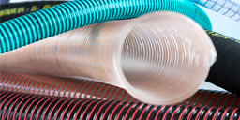  Hoses, Hose fittings | Rubber water hose, EPDM water hose, EPDM-radiator hose, High-flexible PVC suction and pressure hose, Rubber spiral suction and pressure hose… |  | 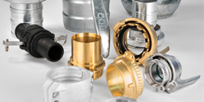  Valves | Sleeve ball valve,  Grey cast iron flange ball valve,  Backflow preventer,  Cast iron knife gate valve…
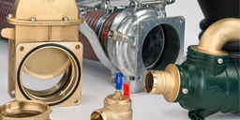  Agricultural engineering | MZ brass lever gate valve,  RIV brass slurry flange gate valve,  Flange,  Impeller holder with perforated square pipe... |  | 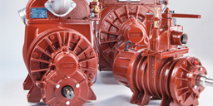  Vacuum pumps | Jurop-vacuum pump,  Suction conveyor,  Jurop-rotary pistion pump…
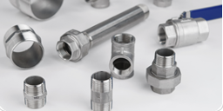  Fittings  PVC-PE/ Stainless steel |  | Pipes,  Bends,  Flanges,  Clamping connections,  Hose nozzles,  Ball valves,  Gas ball valves,  and more | 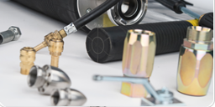  Cleaning engineering |  | Spray guns,  High pressure, nozzles,  Couplings,  Turn-off valves,  Cleaning nozzles,  and more

For further information please visit our website.
If you have any questions, please do not hesitate to contact us.

